Encoding Categorical Variables Using One-Hot Encoding
The dataset contains both numerical and categorical features. Machine Learning algorithms such as K-Means Clustering and Artificial Neural Networks (ANNs) cannot directly process textual categorical values such as:
- Male, Female
- Yes, No
- Fiber Optic, DSL, Cable

Therefore, categorical variables must be converted into a numerical format before model training. To achieve this, One-Hot Encoding was applied. This technique transforms each category into a separate binary column containing values of either 0 or 1.
One-Hot Encoding is preferred because it prevents the model from assuming any ordinal relationship between categories. For example, assigning numerical values such as 1, 2, and 3 to service types could incorrectly imply that one category is greater than another.

Implementation
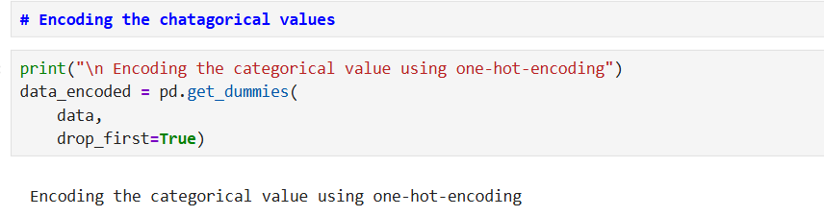
Outcome
The encoding process:
- Creates new binary columns for each categorical value.
- Converts all categorical features into a machine-readable numerical format.
- Removes the first category from each feature (drop_first=True) to reduce multicollinearity and avoid the dummy variable trap.
- Produces a fully numeric dataset suitable for machine learning algorithms.

2. Feature Scaling Using StandardScaler
After encoding, feature scaling was performed using the StandardScaler technique. Scaling is an essential preprocessing step because machine learning algorithms such as K-Means and Artificial Neural Networks are highly sensitive to differences in feature magnitude.
Without scaling:
- Features with larger numerical values can dominate the learning process.
- Distance-based algorithms such as K-Means may produce biased clusters.
- ANN training may converge more slowly and produce less reliable results.
StandardScaler standardises each feature by transforming it to have:
- A mean of 0
- A standard deviation of 1
This ensures that all features contribute equally to the model.

Implementation
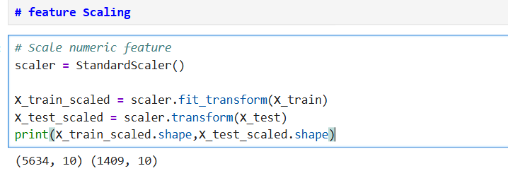
Outcome
The scaling process:
- Fits the scaler on the training dataset only.
- Applies the same transformation to both training and testing datasets.
- Prevents data leakage by ensuring information from the test set is not used during training.
- Improves model stability, convergence speed, and overall performance.
- Produces standardised datasets ready for clustering and ANN model development.

